# 1 - Introduction

The targets imposed by the European community impose the reduction of consumption by 2030 and in this perspective the reduction of energy consumption in buildings becomes of fundamental importance. It is estimated that most of the consumption comes from the operation 90% of the total energy consumed during the life cycle of a building.

The reduction of energy usage in building could support the urgency to reduce world emissions, though Promote energy awareness and prevent wastes.

A large amount of data is produced by the operation of buildings thanks to the increasingly widespread introduction of IOT devices, reaching zettabyte \cite{ ﻿Erhan2021 }. which have made buildings become not only and energy intensive but information intensive \cite{﻿Fan2021}. Smart cognitive building \cite{﻿Rinaldi2020}

Building data are heterogeneous and reflects the complex interaction that occurs between occupants, energy systems, the building envelope, and external conditions. Managing those data is not trivial \cite{ ﻿Molina-Solana2017 }, however if properly managed and analysed, provide the opportunity to gain insight on the building operational behaviour discovering opportunities for savings. Promoting sustainability behaviour.

A way that has been proved to be effective are Machine learning Data driven approaches can be helpful to variety of tasks: pattern recognition, analysis for performing essential tasks in building energy management such as energy consumption forecasting, anomaly detection and diagnosis, advanced benchmarking, load profiling, and schedule optimization of building energy systems. \cite{ ﻿Molina-Solana2017 }

In this paper we focus on anomaly detection of electrical loads in buildings, that consists in detecting electrical load patterns that deviates from expected behaviour, approach that could assists in reducing energy waste and promote energy efficient behaviour.

## 1.1 – Anomaly detection: related work

An anomaly is a point that deviates from normal expected behaviour:

* A point anomaly means that one individual event instance can be considered anomalous when compared to the remaining data.
* Context anomalies start from the assumption of dividing the behaviour from the context: the same behaviour might not be considered an anomaly if it happens in a different context.
* collective anomaly. In this case, the event instance does not represent an anomaly per se, but only if considered within the collection of all the other events instances.

Anomaly detection can be employed in detecting abnormal behaviour of end users, detection of faulty appliance or energy subsystem and spotting technical and non non-technical energy loss \cite{ ﻿Himeur2020}.

Depending on the detail of electrical load monitored the detection level can be performed at different levels:

* Aggregated level (meter level): consists in analysing the whole building electrical load measured at meter level, without having any information on the disaggregation of that load among the different sub loads or appliances
* Appliance level (sub meter level): consists in identifying anomalies referring to a given appliance, it is performed thanks to sub metering infrastructure that measures every single sub system

\cite{Himeur2020} performs a classification of anomaly detection techniques on algorithmic centric view in building energy systems:

* Supervised anomaly detection requires to train a machine learning algorithm using labelled dataset in order to classify anomalous consumption or not. Although supervised anomaly detection can achieve high-accuracy identification results as demonstrated in academic frameworks, its adoption in real-world is still limited compared to unsupervised methods, due to the absence of power consumption annotated datasets. \cite{Himeur2020}.
  + Deep learning,
  + ANN
  + Regression
  + Probabilistic models
  + Traditional classification
* Unsupervised anomaly detection consists in detecting rare and unknown anomalous energy patterns without any a priori knowledge. It usually consists in modelling the normal behaviour and then identify patterns that deviates, under the assumption that the number of anomalies is low compared to the observations.
  + Clustering, \cite{﻿Voltage2016} performs anomaly detection on smart grid though the use of clustering
  + Dimensionality reduction and classification
* Feature extraction
  + Distance based
  + Time series analysis
  + Density-based
  + Graph-based

## 1.3 - Anomaly detection using Matrix Profile

is at aggregated level unsupervised feature extraction

One of the most promising technique is Matrix profile . Firstly introduced by \cite{﻿Yeh2017d} it is a novel algorithm that performs the all-similarity-join-search among two time series, i.e. finds the nearest neighbour for each object of a data collection.

This problem has always been tackled by a computation al time issue resulting, even for modest datasets, into not reasonable computational time. In literature this issue was addressed by reducing the dimensionality of dataset through PAA in order to speed up computation. However his method causes loss of valuable information. MP proposes a ultra-fast similarity search under the z-Euclidean distance that does not reduce dimensionality, MP in fact calculates the full join, eliminating the need of setting a threshold, making the method almost parameter free. The exact and scalable algorithm allows the method to be incrementally maintainable, deterministic in time and so parallelizable on multicore processor to speed up even further the computations.

Given two time series and a given subsequence length, the matrix profile algorithm produces two new series: the matrix profile and matrix profile index. Matrix profile is a one-dimensional timeseries that stores the z-normalized Euclidean distance between each subsequence of the first series and the closest matching subsequence (i.e. nearest neighbour) of the second time series. Matrix profile index is a one-dimensional timeseries that contains the index of where the nearest neighbour is located in the second timeseries.

In the case the two time series are the same a self-join is performed, additional constraints are added in order to avoid trivial matches where sub sequences match themselves, in particular an exclusion zone is set to avoid neighbour search just before and after the reference subsequence.

Even if different robust distance metrics have been proposed \cite{Gharghabi2020, ﻿Zhu2020}, the original method uses the z-normalized Euclidean distance to calculate the MP, which provides a way to focus on shape instead of amplitude and permits to extract information without having domain knowledge.

Definitions:

* A time series $T \in R^n$ is a sequence of real-valued numbers $t_i \in R : T = \{t_1,t_2 \dots t_n \}$ with $1<i\leq n$ where $n$ is the length of $T$
* A subsequence $T_{i,m} \in R^m$ is a continuous subset of values from $T$ of length $m$ starting from position $i$. Formally defined as $t_i \in R : T_{i,m} = \{t_i,t_{i+1} … t_{i+m-1} \}$ with $1<i<n-m+1$
* An all-sub sequences set $A$ of a time series $T$ is an ordered set of all possible sub sequences of $T$ obtained by sliding a window of length $m$ across $T$. It is formally defined as follows: $A = \{T_{1,m} , T_{2,m} \dots T_{n-m+1,m} \}$ where $m$ is a user-defined subsequence length. We use $A[i]$ to denote $T_{i,m}$
* A distance profile $D_i$ of a timeseries $T$ is a vector of distances between a given query (subsequence $T_{i,m}$) and each subsequence in an all-subsequence set $A$. Formally, $D_i = [d_{i,1}, d_{i,2},\dots, d_{i,n-m+1}]$, where $d_{i,j} = dist(T_{i,m}, T_{j,m})$ for all $j \in [1,2,\dots, n-m+1]$ where $i\neq j$ and $dist$ is the distance metric applied.

The concept behind MP calculation is presented in figure, where self-join MP calculation is performed. Given a timeseries T, by sliding the window of length m, the Euclidean distance d,I,j between the z-normalized sequence T_i,m in the first time series T and z-normalized sequence T_i,m in the second time series is calculated and then stored in a distance profile D. This process is performed for each subsequence of the first time series and the generated distance profile create the so called full distance matrix. By extracting the smallest value in each row/column (the smallest non-diagonal value for the self-join case, A=B) MP is finally generated.

The previously presented method is the naïve implementation of the MP calculation and is the most inefficient since the full distance matrix have to be calculated. Behing the MP algorithm there are more efficient algorithms such as stamp and stomp that provides the complete MP in a more efficient and time saving way

By joining information of MP index and MP many insights could be extracted. The main application is the motif and discord discovery that consists in finding respectively the minimum and the maximum of the MP and locating the nearest neighbour of the subsequence starting in that particular index.

Discord discovery may be interpreted as an anomaly detection method that discovers the most unique sub sequences in a dataset by comparing every sub sequence with all the others. Discord discovery using MP as anomaly detection method has been employed with success in different fields:

informatics

\cite{DinalHerath2019} introduces ﻿a real time anomaly detection framework based on matrix profile called RAMP (Real-Time Aggregated Matrix Profile), that is able to identify anomalies in scientific workflows. (building block).

An industrial application of anomaly detection is presented in\cite{﻿Anton2020} which combines the classical approach of Matrix profile with the hamming distance to automatically detect intrusions in the network of a water processing facility.

\cite{ ﻿DePaepe2020a} Applies a noise elimination technique based on Matrix Profile on real Yahoo! internet traffic metrics to detect anomalous behaviours

\cite{ ﻿DePaepe2019 } demonstrate how the elimination of noise can help in anomaly detection of noisy date by testing the algorithm on numenta benchmark

\cite{ ﻿Madrid2019 } applies the pan matrix profile algorithm to find different length anomalies in ﻿automated pedestrian counting system developed in Taipei

*medicine*

\cite{﻿Alshaer2020} proposes an unsupervised real time anomaly detection method based on continuous learning of time series shaplets extracted though Matrix Profile algorithm. Those shaplets are extracted and stored in an anomaly library and then used for anomaly detection in an electro-cardiogram (ECG) time series (﻿MIT-BIH database [32]), using a in a sliding window.

energy

﻿\cite{ ﻿Nichiforov2020 } Identifies anomalous patterns though a basic application of Matrix Profile on public building energy traces and then classifies the pattern

\cite{ ﻿Zhu2020} demonstrates how Matrix Profile can be useful in detecting anomalies in different fields in particular in meter swapping and earthquake monitoring.

\cite{﻿DePaepe2020b} applied an implementation of the classic Matrix Profile, called Contextual Matrix Profile, in detection of anomalous energy consumption on a ventilation units of three households.

## 1.4 - Problem of classic approach and improvements

From the previous literature review it emerges that the MP method have been employed successfully in different fields for anomaly detection and the authors have proposed different implementations according to the field of interest. In fact, even if MP is an unsupervised method useful for discord discovery every field have different boundary conditions and different restrictions that cannot be overlooked. In the field of building, the most interesting timeseries are those related to energy consumption. Those timeseries are strictly correlated to many different variables such as occupation, weather conditions, energy systems and so on. A completely unsupervised method may fi by its nature to consider the relation with those variables and extract ineffective or trivial results, not useful for anomaly detection.

In building an anomaly is an unexpected behaviour that consists in a strongly different energy consumption. The classic MP (with z-score normalization) may fail to identify this kind of anomaly while is effective in identifying anomalous shapes. MP searches NN based on shape similarity. However anomalous shapes not always correspond to anomalous energy consumption, as well as similar shapes in z score not always reflect similar

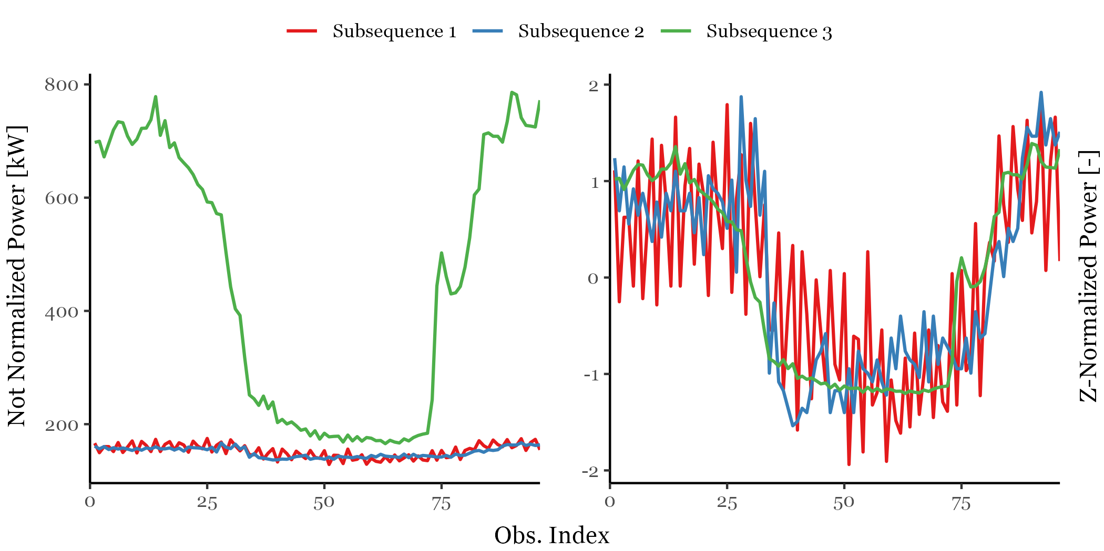

The effect of zscore normalization not only avoid to take into account the magnitude of the time series but also tends to score different subsequences that are relatively flat. This issue have been largely analyzed in \cite{} where it is proposed a to smooth …

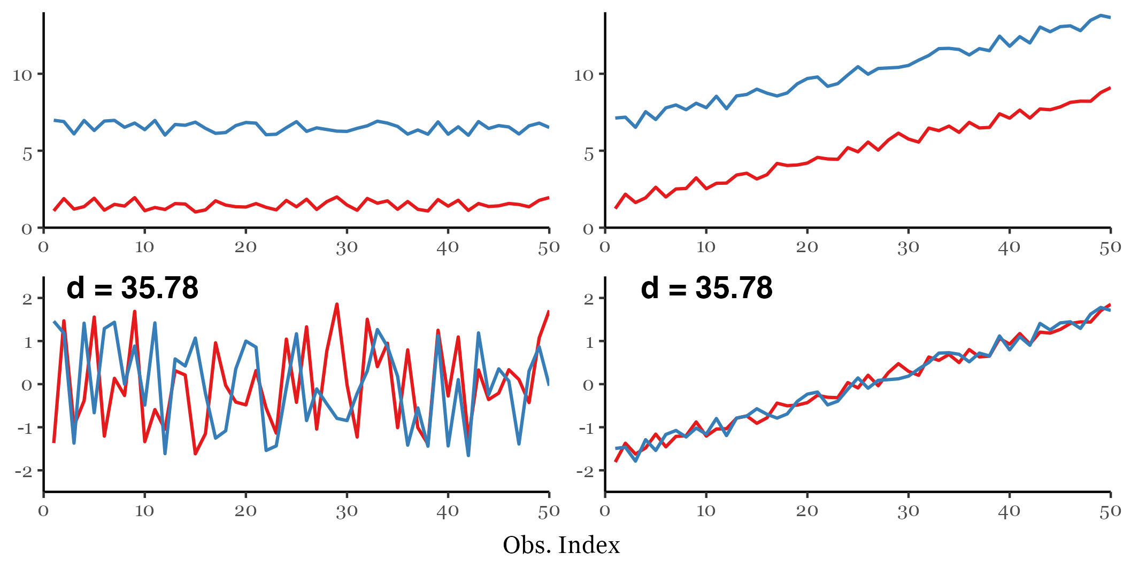

Moreover the energy consumption pattern changes between weekdays and weekends/holiday, so it would be unfair comparison to compare sub sequences pertaining to these groups, the same is to compare sub sequences of night hours and daily hours. Introducing domain knowledge to find discords only in sone sub groups of the timeseries became important.

﻿\cite{Dau2017} introduces the concept of annotation vector used to introduce domain knowledge in the process of motif and discord discovery, which allows to find results that follows users defined constraint and produce better results, closer to expectations of the analyst. This method has been proved to be effective to solve different issues: simplicity bias, actionability bias.

However, this method is a posteriori method that does not modify the way MP is calculated, in particular all-pairs similarity search is always performed and then some regions are excluded form motif/discord search. Sometimes it can be useful to exclude some region or to group sub sequences into different groups and then perform the similarity search in order to discover anomalies by comparing only the interesting regions and excluding others. A solution to this problem have been proposed by \cite{DePaepe2020b} where CMP algorithm permits to define ranges along T1 and T2 and look for the best matching subsequence among these ranges. This permits different grouping before the MP calculation thus providing different insights.

Twin freak

﻿For a given sub-sequence, Matrix Profile computes the Euclidean distance with respect to all other sub- sequences and identifies the minimum distance. Therefore, a repeated anomaly instance would cause false negatives due to the previous anomaly instance being part of the all sub- sequence set.

Specifically, frequent/rare sub sequences are defined as the ones with the smallest/largest 1-nearest neighbour distance, which are also known as motif/discord. However, discord fails

the ones with the smallest/largest 1-nearest neighbour distance, which are also known as motif/discord. However, discord fails to identify rare sub sequences when it occurs more than once in the time series, which is widely known as the twin freak problem.

\cite{DinalHerath2019} through a semi-supervised model permits to limits the number of sub sequences compared, considering for comparison only references with no anomalies.

\cite{﻿He2020} proposes a method called “Neighbour Profile” based on sampling and density estimation to perform anomaly detection and overcame the issue of twin freak.

# 2.- Contribution of the paper

# 3.-Description of the Data Analysis Methods

Contextual Matrix Profile

Anomaly score

CART

classification

# 4. - Methodological Framework

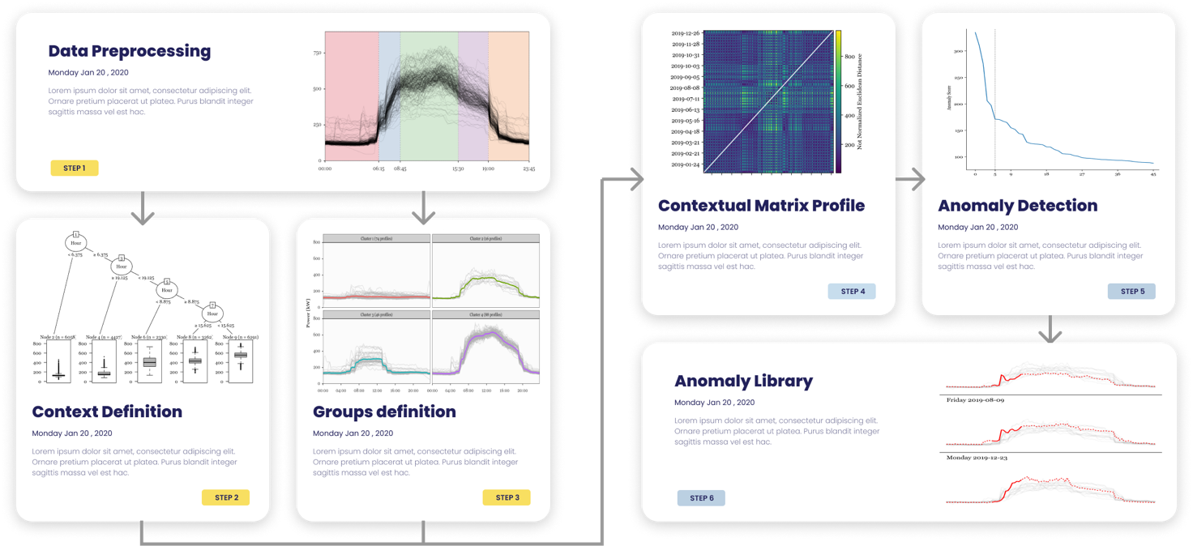

Framework generale e pseudocodice?

# 5. - Case study

The case study analysed refers to the energy consumption of a MV/LV transformer cabin identified as “substation C”, that serves a part of the main campus of Politecnico di Torino (PoliTo), an Italian university located in Turin. The measurement infrastructure provides the total electrical load with 15 min timestamps. In order to use a dataset that is large enough to capture the behaviour of the electrical load, with regular occupation patterns

# 6. - Results

# 7. - Discussion

# 8. - Conclusions and Future Work